Name: Jayson Q. Barrina
Yr and Section: 3-BSCS-B
Subject: APP DEV
Title: Types of Data Bases

TYPES OF DATA BASES

Relational Databases
In a relational database management system (RDBMS), the relationship between data is relational and data is stored in tabular form of columns and rows. Each column of a table represents an attribute and each row in a table represents a record. Each field in a table represents a data value.
Structured Query Language (SQL) is the language used to query RDBMS, including inserting, updating, deleting, and searching records. Relational databases work on each table that has a key field that uniquely indicates each row. These key fields can be used to connect one table of data to another.
The relational database has two major advantages:
- Relational databases can be used with little or no training.
- Database entries can be modified without specifying the entire body.
Properties of Relational Tables
In a relational database, we have to follow the properties given below:
- Values are Atomic
- Each Row is alone.
- Column Values are the same thing.
- Columns are undistinguished.
- Sequence of Rows is Insignificant.
- Each Column has a common name.

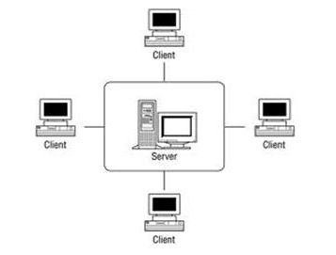

Graph Databases
Graph Databases are NoSQL databases and use a graph structure for semantic queries. The data is stored in the form of nodes, edges, and properties. In a graph database, a Node represents an entity or instance such as a customer, person, or car. A node is equivalent to a record in a relational database system. An Edge in a graph database represents a relationship that connects nodes. Properties are additional information added to the nodes.
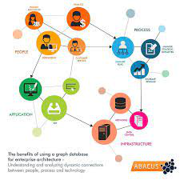
The Neo4j, Azure Cosmos DB, SAP HANA, Sparksee, Oracle Spatial and Graph, OrientDB, ArrangoDB, and MarkLogic are some of the popular graph databases. Graph database structure is also supported by some RDBMS including Oracle and SQL Server 2017 and later versions.

Document Databases
Document databases (Document DB) are also NoSQL databases that store data in the form of documents. Each document represents the data, its relationship between other data elements, and attributes of data. Document database store data in a key-value form.
Document DB has become popular recently due to their document storage and NoSQL properties. NoSQL data storage provides a faster mechanism to store and search documents.
Popular NoSQL databases are Hadoop/Hbase, Cassandra, Hypertable, MapR, Hortonworks, Cloudera, Amazon SimpleDB, Apache Flink, IBM Informix, Elastic, MongoDB, and Azure DocumentDB.
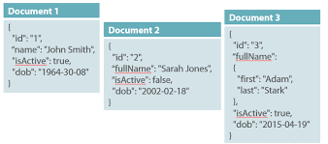

Analytical (OLAP)
Online Analytical Processing (OLAP) is a category of software that allows users to analyze information from multiple database systems at the same time. It is a technology that enables analysts to extract and view business data from different points of view.
Analysts frequently need to group, aggregate and join data. These OLAP operations in data mining are resource intensive. With OLAP data can be pre-calculated and pre-aggregated, making analysis faster.
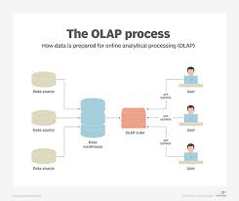
OLAP databases are divided into one or more cubes. The cubes are designed in such a way that creating and viewing reports become easy. OLAP stands for Online Analytical Processing.

Key-value databases
Key-value databases, also called key-value stores, are often considered the simplest type of NoSQL databases. Each unique identifier is stored as a key with its associated value. The value can be any sort of byte array, data structure, or binary large object (BLOB), and works well for storing enormous amounts of data. Windows Explorer and Apple Finder are both key-value databases.
Good Key-Value Database Use Cases Include:
- Scalable data
- Profiles, preferences and configurations
- Cache management
- Blockchain implementation
- Multimedia storage or large objects (video, images, audio, etc.)
Key-value stores are not considered suitable for applications requiring frequent updates or for complex queries involving specific data values, or multiple unique keys and relationships between them.

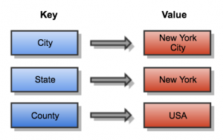

Column-Family
A column store database is a type of database that stores data using a column oriented model.
A column store database can also be referred to as a:
- Column database
- Column family database
- Column oriented database
- Wide column store database
- Wide column store
- Columnar database
- Columnar store
Columns store databases use a concept called a keyspace. A keyspace is kind of like a schema in the relational model. The keyspace contains all the column families (kind of like tables in the relational model), which contain rows, which contain columns.
